MACHINE LEARNING ALGORITHMS FOR SOLVING REAL-WORLD CHALLENGES
Abstract: The current analysis is based on the use of machine learning regression to forecast the sales of the dresses based on the Dresses attribute dataset and the Dress Sales dataset. The question to be answered is whether yielding to product level characteristics- about the style, material, neckline, season, type of fabric and ornamentation- can bearfully predict the consumer buying behaviour. Three machine learning models were compared: linear regression, random forest regression, and support vector regression (SVR). The data sets were consolidated and pre-treated to process categorical variables, date-based sales values and inconsistencies. Findings indicate that predictive power is low, with Random Forest giving the most favourable result (RMSE 0.15816; R 2 0.14) in terms of scores. Linear Regression has an adequate level (R 2 = 0.04) whereas SVR has a poor level (R 2 = 0). The results indicate that dress properties do not adequately address the differences in sales, and other characteristic variables such as the price patterns, promotions, and the patterns of visibility, are needed to make the modelling robust. The report ends by reiterating the difficulties of using regression on sparse retail data and suggests ways in which future studies might improve predictive accuracy more accurate.
Keywords: Machine Learning, Regression Analysis, Retail Forecasting, Dress Sales Prediction, Random Forest Regression, Linear Regression, Support Vector Regression, Categorical Attribute Modelling, Data Pre-processing, Fashion Analytics, Predictive Modelling, Dataset Integration

I. INTRODUCTION
The growth of online shopping has generated so much information about the products that firms have a chance to examine the customer tastes and optimize their merchandising strategies. With the increased adoption of e-commerce platforms, the capacity to predict the demand and supply trend of sales becomes more critical when it comes to controlling stock holdings, customer satisfaction, and revenue maximization. Machine learning has emerged to be a critical tool in this field since it is capable of detecting small patterns in information and predictions that cannot be seen via simple manual examination. The retail settings can be characterized by numerous overlapping factors, and the model can be used to reveal the relations between the features of the products and the buyer behavior. Not every dataset will, however, provide the richness that is required to make high-quality predictions. Most of the existing retail data sets include only the fixed product features, which provide a shallow understanding of how sales are affected. Key factors like customer behaviour, changes in price, exposure to marketing, as well as seasonality are frequently absent. This makes it difficult to have a good predictive model, and it is doubtful whether product characteristics are enough to predict sales. The presence of these limitations is critical to the exploration of the machine learning behaviour under the limited conditions. This paper makes use of the dress sales data to examine the capacity to make meaning using attribute-based data, and it measures the degree to which various regression methods react to these limitations.

II. RELATED WORK
Retail analytics Research that has progressively concerned this area has centered on how machine learning can improve sales projections and how understanding consumer behavior can be achieved with the use of machine learning [1]. Above and below, much of the existing work emphasizes the fact that visual appeal combined with the price, seasonal pattern and marketing exposure determines the sale of the product. Research with fashion data usually focuses on how crucial it is to consider the temporal patterns, and this shows that sales vary considerably at various times and are much influenced by promotions or external events. The results of research on product metadata indicate that fixed features, including style, material, or color, may offer valuable signals, though on their own they may not offer a sufficient explanation of demand [2]. Consequently, behavioral data or browsing activity-based or social media-based models are likely to be more predictive. Empirical work comparing regression and tree-based models tends to indicate that nonlinear methods are better at dealing with categorical fashion features, which tend to cooperate in more complicated effects. Random forests and gradient boosting ensemble models seem to be notably effective at capturing hidden underlying patterns of structured retail data [1]. Nonetheless, research also observes that limited datasets with numerous gaps in them usually depress the capacity of even sophisticated models. This literature gives a background of reviewing the performance of attribute-driven prediction in cases where no temporal and behavioral factors are present.

III. PROBLEM AND DATASET DESCRIPTION

A. Problem Statement
The main issue discussed in the research design is whether the sales of dresses could be accurately predicted with the help of the product-level characteristics and the previous sales prices [3]. The problem is defined as a regression problem where one is to predict the total sales of each dress, without depending on some characteristics, including style, season, neckline, material and rating of the dress. This relationship is important as insight into it helps in proper prediction of sales to aid in managing stock, in making price-related decisions, as well as in marketing in retail-based facilities [4]. In the case of fashion retailers in particular, demand is frequently unstable and the recognition of the traits of the products that elevate sales may promote design decisions and inventory management. Without a large amount of behavioral data, businesses may make informed decisions, even using simplistic attributes in situations where they can reliably predict. This research is thus an inquiry into the possibilities and shortcomings of using only the existing product information to learn about the buying behavior of consumers in the fashion industry.

B. Dataset Description
Dataset Link:
https://archive.ics.uci.edu/dataset/289/dresses+attribute+sales
The research applies two related datasets, namely, the Dresses Attribute Dataset and the Dress Sales Dataset, which present two opinions on the performance of products. The attribute dataset has descriptive details of each dress, which have been identified by a special identifier, DressID. It entails style, price, rating, size, season, neckline, sleeve length, waistline, material, fabric type, decoration, pattern type, and recommendation label [5]. These variables combine aesthetic and physical features of any product to end up with the set of features to use in modelling. The Dress Sales Dataset presents sales data in the past on a number of dates. The dates are considered as independent columns and the values are the quantity of units being sold on that particular day. Since the dataset cuts across a lot of days and a considerable number of them contain missing or zero entries, a consolidated TotalSales variable will be created as a summation across all days [6]. This is the target variable, which will define the overall demand of every dress. These two datasets are combined with the help of Dress_ID, which creates a single table that correlates the attributes of products with their sales results.

IV. METHODS
The research employs three regression methods to determine the ability of dress characteristics to forecast the overall sales. Linear regression is the control model, which provides a simplistic method of estimating the correlations of product characteristics and sales. It is very effective with linear patterns, although it has trouble interacting with irregularities, which are prevalent in fashion data [4]. Random Forest Regression is a more flexible approach to the ensemble-based approach that is able to run several decision trees together. This gives the model the capability to form nonlinear behavior and variable interactions and minimizes the possibility of overfitting [5]. It is especially appropriate to mix categorical attributes present in this data. Support Vector Regression also offers another nonlinear model because it utilizes a kernel to model more complex relationships. It is included because it is very sensitive to noisy/sparse data and heavily scaled features, which is why, unlike other modelling strategies, it is susceptible to the limitations of the dataset.

V. EXPERIMENTAL SETUP
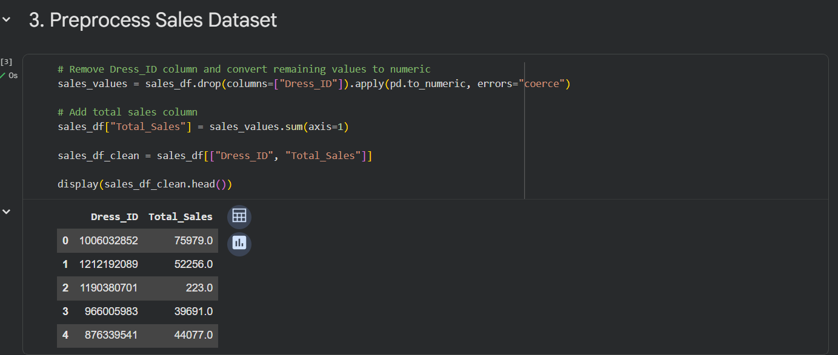
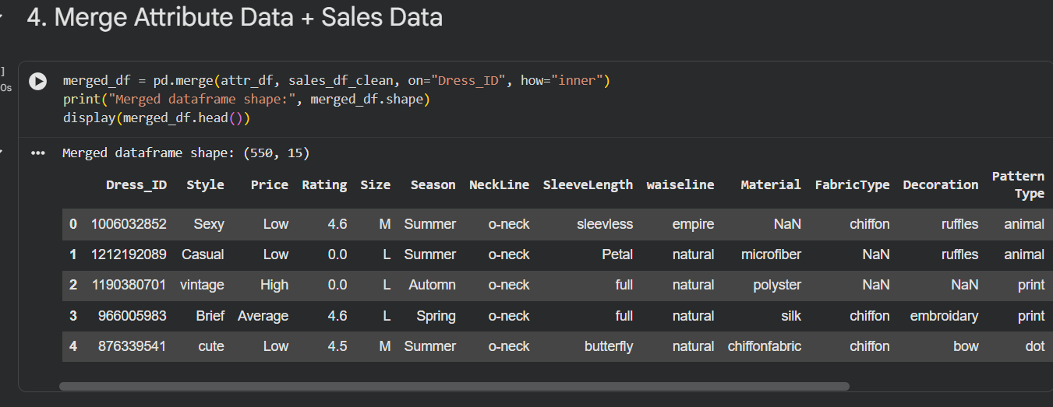
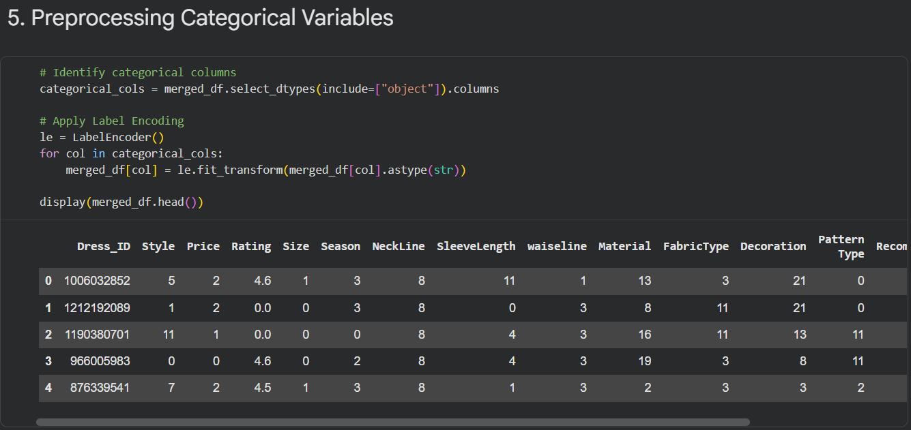
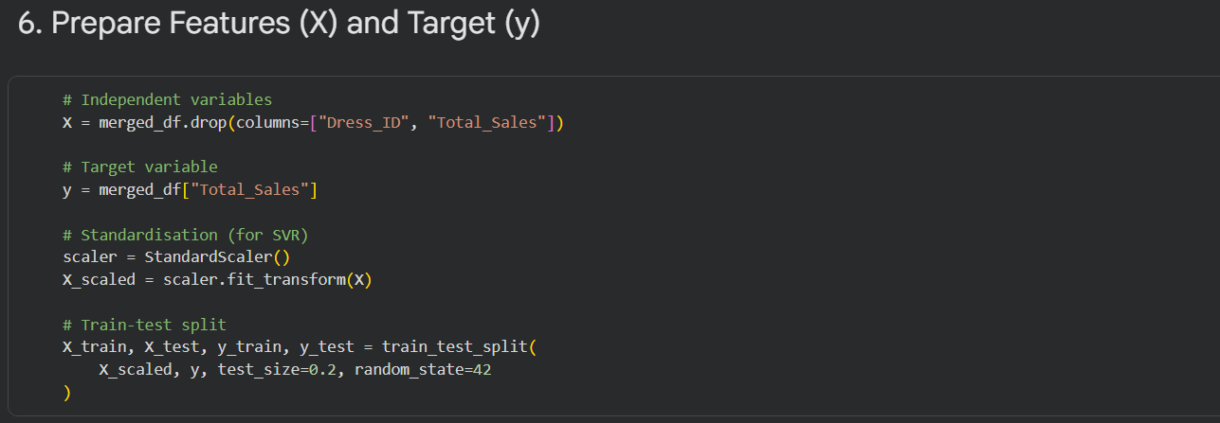
Figure 1: EXPERIMENTAL SETUP
The codification of the experiment entailed the preparation of the two datasets in order to have uniformity during the training of the models. Many of the missing values in the sales file were in the date columns of the file; therefore, each column was changed to numeric and those that were not valid were considered as missing. Then, a target variable was developed through the addition of the sales on all the available dates as one target variable of overall demand [6]. The data set of attributes included mostly the descriptors, which are categorical, which are style, material, and pattern. Label encoding was used to encode these to a numerical value without making the feature space large. Both datasets then to be used were cleaned and then combined using the Dress_ID field to correlate the attributes associated with the product to the total sales of that product [7]. The identifier was also eliminated because it was not predictive. Since one of the models needed standardized input, all the features were normalized then the data were split into training and testing sets with an eighty-twenty split.
VI. RESULTS
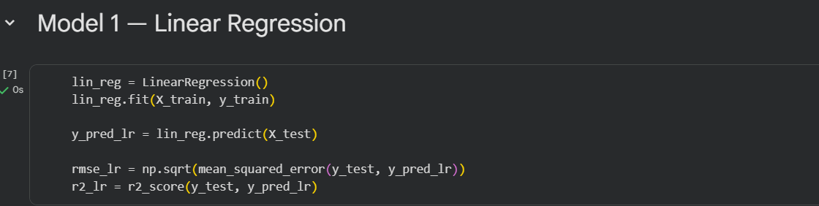
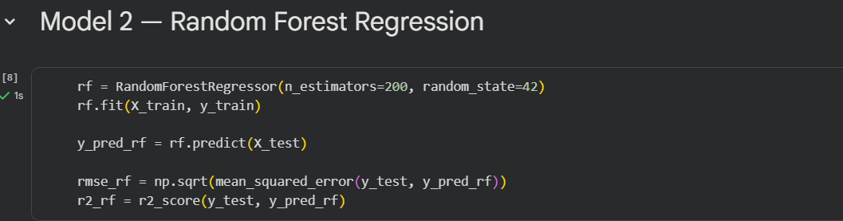
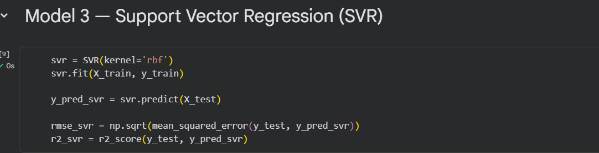
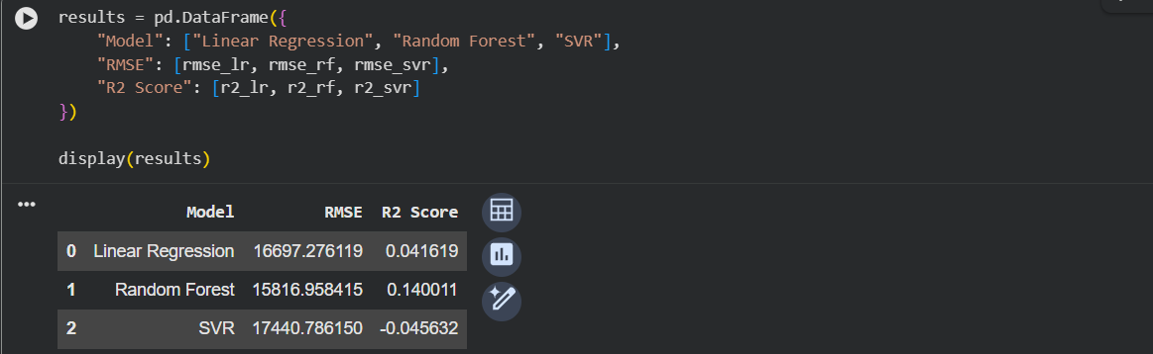

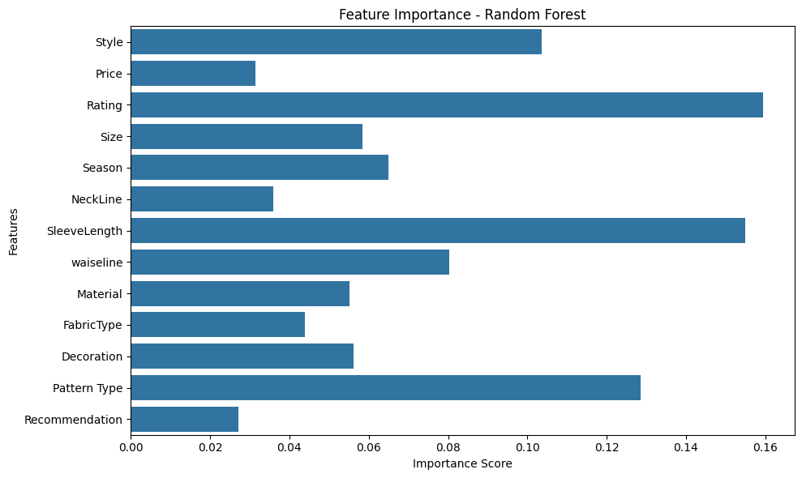
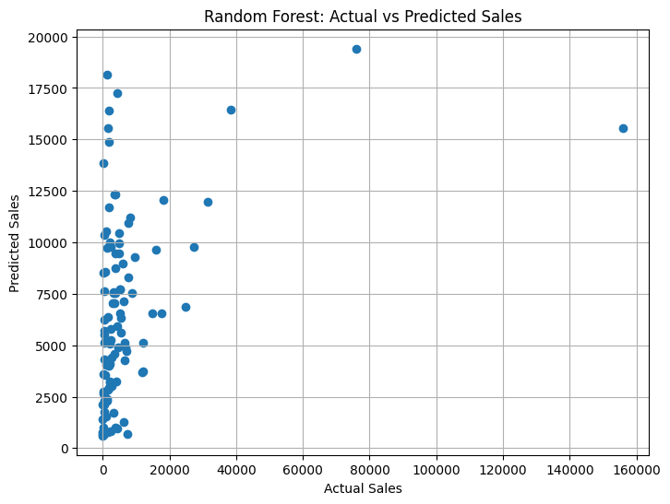
Figure 2: RESULTS
The discussion reveals that there are obvious differences in the way the three regression models explain the presence of a relationship between dress attributes and total sales. Random Forest offers the best performance and its R 2 rate of 0.14 indicates that it only reflects a marginal part of the variation in sales underlying. This implies that the data has weak patterns with detectable patterns. The Linear Regression has only a very little better performance than that of chance, which implies that there would be very little linear relationship between product properties and sales. The reason why SVR does not do as good as a baseline predictor is that it cannot easily model the sparse and heavily categorical data. Analysis of the importance of features in the random forest model indicates that none of the attributes is critically important to the predictions and the contributions are thinly spread across style, season, rating, and price variables. These results are relevant to highlight that the attributes at hand provide limited predictive powers of dress sales, as they can be explained or forecasted.
VII. DISCUSSION AND CONCLUSIONS
The research aimed at determining whether only product attributes and aggregated sales could be used to predict the dress sales. These findings are clearer in demonstrating the fact that such minimal information sets a poor basis for correct forecasting. The three regression models had difficulties finding significant trends, which was mostly caused by the lack of unity and density of the sales data and richer behavioral cues [8]. By using both the different dates of sales in the same target, the temporal variation was eliminated and the use of the categorical aesthetic attributes limited the model's ability to predict the real aspects that have a lasting impact on demand. It was noted that, in spite of the fact that Random Forest was able to unearth the small nonlinear patterns, its results were poor, meaning that the dataset was not deep enough to support the strength of regression modelling [9]. These results demonstrate that extensive datasets are essential in retail formation missions. More specific variables will be required to generate accurate and practical forecasts like price fluctuations, promotions of different products, and communication with customers.

REFERENCES
[1] Chen, I.F. and Lu, C.J., 2021. Demand forecasting for multichannel fashion retailers by integrating clustering and machine learning algorithms. Processes, 9(9), p.1578.
[2] Chen, D., Liang, W., Zhou, K. and Liu, F., 2022. Sales forecasting for fashion products considering lost sales. Applied Sciences, 12(14), p.7081.
[3] van der Kaaij, Q. and Guszti Eiben, V.U., 2024. Leveraging machine learning algorithms to improve fashion demand forecasting.
[4] Bedi, T., Pandit, A. and Gautam, N., 2024, October. Demand forecasting of online retail of fashion apparel using machine learning-A systematic review and a proposed methodology. In AIP Conference Proceedings (Vol. 3209, No. 1, p. 040008). AIP Publishing LLC.
[5] Chang, A.A., Cynthia, Devita, Ramadhan, J.F., Adnan, Z.K.S., Kanigoro, B. and Irwansyah, E., 2021. Fashion trend forecasting using machine learning techniques: a review. Proceedings of the Computational Methods in Systems and Software, pp.34-44.
[6] Koren, M., Abulafia, N., Shviro, L. and Weiss, N., 2024, December. A Machine Learning Approach to Forecasting Demand in Fashion Industry. In 2024 4th International Conference on Advanced Enterprise Information System (AEIS) (pp. 52-56). IEEE.
[7] Tezcan, E. and Zaim, A.H., 2025, September. Cold-Start Sales Forecasting in Fashion via Feature-Based Ensembles. In 2025 10th International Conference on Computer Science and Engineering (UBMK) (pp. 757-762). IEEE.
[8] Kutlu, A.A., 2024. Predictive Modeling of Return Occurrence in E-Commerce Apparel Market: A Comparative Study of Logistic Regression, LASSO, XGBoost and Random Forest Techniques (Master's thesis, Bilkent Universitesi (Turkey)).
[9] Iyer, N., Singh, R., Patel, S. and Singh, A., 2021. Enhancing Retail Sales Forecasting with LSTM Networks and Random Forest Regression: A Comparative Analysis. Journal of AI ML Research, 10(8).
[10] Rout, D., Roy, B. and Kapse, P., 2023, September. A subtle design of prediction models using machine learning algorithms for advocating selection and forecasting sales of garments: A case study. In International Conference on Advances in Data-driven Computing and Intelligent Systems (pp. 387-397). Singapore: Springer Nature Singapore.

APPENDIX
Import Libraries
# Core libraries
import pandas as pd
import numpy as np

# ML libraries
from sklearn.model_selection import train_test_split
from sklearn.preprocessing import LabelEncoder, StandardScaler
from sklearn.linear_model import LinearRegression
from sklearn.ensemble import RandomForestRegressor
from sklearn.svm import SVR

# Metrics
from sklearn.metrics import mean_squared_error, r2_score

# Visualisation
import matplotlib.pyplot as plt
import seaborn as sns
# Paths in Google Colab
attribute_path = "/content/Attribute DataSet.xlsx"
sales_path = "/content/Dress Sales.xlsx"

# Load data
attr_df = pd.read_excel(attribute_path)
sales_df = pd.read_excel(sales_path)

print("Attribute Data:")
display(attr_df.head())

print("Sales Data:")
display(sales_df.head())
# Remove Dress_ID column and convert remaining values to numeric
sales_values = sales_df.drop(columns=["Dress_ID"]).apply(pd.to_numeric, errors="coerce")

# Add total sales column
sales_df["Total_Sales"] = sales_values.sum(axis=1)

sales_df_clean = sales_df[["Dress_ID", "Total_Sales"]]

display(sales_df_clean.head())
merged_df = pd.merge(attr_df, sales_df_clean, on="Dress_ID", how="inner")
print("Merged dataframe shape:", merged_df.shape)
display(merged_df.head())
# Identify categorical columns
categorical_cols = merged_df.select_dtypes(include=["object"]).columns

# Apply Label Encoding
le = LabelEncoder()
for col in categorical_cols:
merged_df[col] = le.fit_transform(merged_df[col].astype(str))

display(merged_df.head())
# Independent variables
X = merged_df.drop(columns=["Dress_ID", "Total_Sales"])

# Target variable
y = merged_df["Total_Sales"]

# Standardisation (for SVR)
scaler = StandardScaler()
X_scaled = scaler.fit_transform(X)

# Train-test split
X_train, X_test, y_train, y_test = train_test_split(
X_scaled, y, test_size=0.2, random_state=42
)
rf = RandomForestRegressor(n_estimators=200, random_state=42)
rf.fit(X_train, y_train)

y_pred_rf = rf.predict(X_test)

rmse_rf = np.sqrt(mean_squared_error(y_test, y_pred_rf))
r2_rf = r2_score(y_test, y_pred_rf)

svr = SVR(kernel='rbf')
svr.fit(X_train, y_train)

y_pred_svr = svr.predict(X_test)

rmse_svr = np.sqrt(mean_squared_error(y_test, y_pred_svr))
r2_svr = r2_score(y_test, y_pred_svr)

results = pd.DataFrame({
"Model": ["Linear Regression", "Random Forest", "SVR"],
"RMSE": [rmse_lr, rmse_rf, rmse_svr],
"R2 Score": [r2_lr, r2_rf, r2_svr]
})

display(results)

importances = rf.feature_importances_
feature_names = X.columns

plt.figure(figsize=(10,6))
sns.barplot(x=importances, y=feature_names)
plt.title("Feature Importance - Random Forest")
plt.xlabel("Importance Score")
plt.ylabel("Features")
plt.tight_layout()
plt.show()
plt.figure(figsize=(8,6))
plt.scatter(y_test, y_pred_rf)
plt.xlabel("Actual Sales")
plt.ylabel("Predicted Sales")
plt.title("Random Forest: Actual vs Predicted Sales")
plt.grid(True)
plt.show()

